Neighbourhood Warden Update

It seems remarkable that we are soon approaching the anniversary of the outbreak of the Covid-19 Pandemic. Although everyone knows there is hope, they also know there is some way to go and more sacrifices are to be made before we can return to some sort of normality.

Whilst being on patrol and talking to people it is clear to us and our PSCO’s that the overwhelming majority of residents of both Bramber and Upper Beeding have followed the guidelines and adhered to restrictions. The response and coming together of the community and the volunteer effort is truly amazing.

Unfortunately, some groups of young people have not been following the rules and we urge parents and carers to express the importance of the restrictions to their children to protect the whole community. PCSO’s can and will issue fines for breaches and will be carrying out visits to parents whose children are not complying with the restrictions (a full explanation of the guidelines can be found on the Horsham District Council website)

It is even more important that we continue to follow the guidelines and support each other as the restrictions allow. Picking up the phone, running an errand or doing some shopping for a lonely or vulnerable neighbour or friend may just make their day. We may also be able help or signpost so please do not hesitate to contact us. We realise that the winter months are always more challenging for many and with the restrictions set to be in place for some time we need to look after each other.

Finally, please remember; wear a face covering, only go out if you need to, stay local, wash your hands frequently and stay safe.

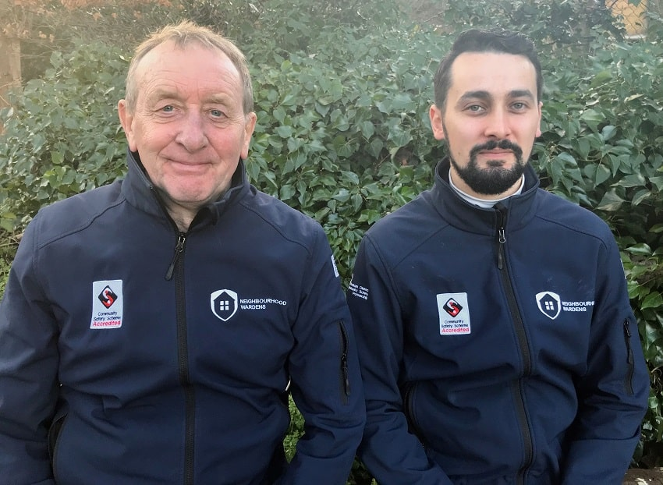

Paul Conroy (07734 387888) and Michael Pearce (07734 387889)
Neighbourhood Wardens

